As part of its continuing series of events on Commemoration, IPUP (Institute for the Public Understanding of the Past) is hosting the following workshop event:

Commemorating the Oaks Colliery Disaster

Bowland Auditorium, Berrick Saul Building, University of York
Thursday 1 December 2016, 10.00 am – 1.00 pm
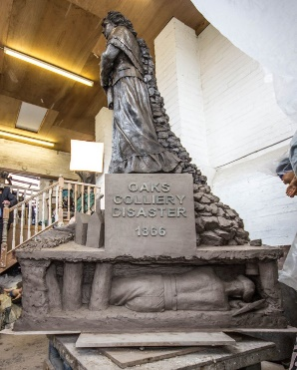
The disaster at the Oaks Colliery near Barnsley, which killed at least 361 people in two explosions on 12-13 December 1866, was at the time the largest mining disaster in the world and attracted global coverage; it remains the largest in English history. In addition to its catastrophic impact on the local community, and the many examples of tragic, moving, heroic and even miraculous survival stories it generated, the disaster is also a landmark moment in debates over safety in the mining industry and social welfare generally at a pivotal point in their history.

December 2016 marks the 150th anniversary of the disaster. The anniversary has been the occasion for a significant volume of commemorative activity, involving a wide range of local and national groups and organizations. The National Union of Mineworkers (NUM) commissioned a memorial to those who died in the disaster, sculpted by the well-known sculptor Graham Ibbeson. The statue has been designated by HM Government as a national monument. The registered charity People and Mining has raised money (£110, 000) to fund the memorial. They are supported in this by a steering committee involving representatives of local volunteer organisations, including local schools and the National Mining Museum. The Heritage Lottery Fund (HLF) have helped to fund an educational package – including a film as well as written materials - to raise awareness of the disaster nationally as well as locally. The Dearne Valley Landscape Partnership have undertaken extensive genealogical research on the identity of victims and have curated an exhibition, When the Oaks Fired, scheduled for December at Barnsley Metropolitan Borough Council’s Experience Barnsley Museum – including an innovative VR installation reconstructing the first-hand experience of the explosion for visitors.

Bringing together many of those who are actively involved in these 150th anniversary initiatives, the Workshop will be an opportunity to discuss the commemorative process, its challenges and tensions and practicalities, the interests and perspectives and emotions that it activates, and to explore the meanings and resonances that are attached to the Oaks Disaster in history and in memory. Both for those who are interested in the study of commemorative events, and for those themselves involved in organising them, the workshop will offer a fascinating insight into commemoration in practice. It will also be of strong interest to anyone with an interest in the mining industry and mining communities, in nineteenth-century campaigns for industrial safety, in the memory politics of post-industrial societies, the public functions of sculpture, the uses of participatory research, applications of virtual reality in museums, or in the local histories of South Yorkshire – and will include the opportunity to view a model of the statue herself.

Participants will include:

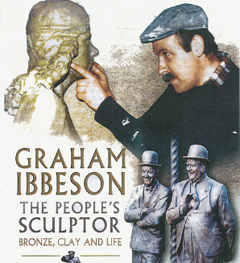
Graham Ibbeson,MA (RCA) is known as The People's Sculptor as he has done over 30 public bronze sculptures, including The Spirit of Jarrow (in Jarrow) and the recently unveiled statue of Morecambe and Wise in Blackpool featured on BBC, ITV and Sky News.. His work can be found in the British Museum and the Victoria and Albert Museum, and has been unveiled by the Queen herself. He is the subject of a biography by John Threlkeld. Graham is a descendant of one of the disaster victims. See his website: http://www.grahamibbeson.com/.

Dr. Stephen Miller, Dearne Valley Landscape Partnership Community Officer for Barnsley Metropolitan Borough Council led a team of volunteers doing genealogical research in local archives to accurately identify the victims, conducts guided tours of significant sites related to the disaster, and curated the exhibition "When the Oaks Fired".

Barry Moore, Treasurer of the People and Mining Charity, is himself an ex-miner, is also a descendant of one of the victims, and represents this active group of volunteer fundraisers who have organised a range of collections and performance events featuring bands, choirs, musicians and a theatre group.

Paul Hardman, NUM National Executive Officer coordinates a range of activities relating to the memorial, including research in the NUM’s own extensive archive, promotional materials, grant administration and support for the Remember the Oaks working party.

Paul Darlow, Heritage Lottery Fund Project Officer is an ex-miner and teacher who has played the lead role in developing educational materials for local and national schools.

Chris Skidmore, in his capacity as Chair of Yorkshire NUM, has responsibilities that include involvement with educational projects and memorial events.

The event will be chaired by Stephen Linstead D.LItt, FAcSS, FRSA Professor of Management at The York Management School, who has coordinated a collaborative internship with IPUP evaluating source materials, and is making a film for HLF on the disaster. His first documentary, These Fragments (2015) on the erasure of the memory of mining in South Yorkshire, received fifteen Official Selections at International Film Festivals including being a semi-finalist for Best British Short.

The programme will include 20-30 minute talks by Graham Ibbeson and Stephen Miller, and shorter presentations by other participants.

All welcome! To reserve a place, please register here . There is no charge for admission.

For further information, both on this event and on the IPUP Commemoration series more generally, contact Geoff Cubitt ( geoff.cubitt@york.ac.uk ).

